**JUEL TOURS**

**3 days Mombasa holiday package ( The Mashujaa holiday)**

**Places to visit**

1. **Haller park**

* Experience variety of plants and animals in their natural habitat. Examples are –

Giraffes, elands, Oryx, tortoise, Hippo and crocodiles.

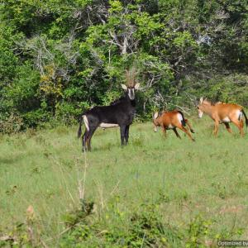 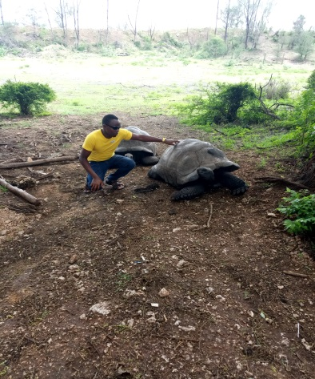

1. **Mamba Village**

Get a first hand encounter with crocodiles at mamba village. This is the largest crocodile firm in Africa. You also have a chance to see different types of snakes. You can also enjoy a horse ride and finally have a taste of crocodile meat which is so delicious.

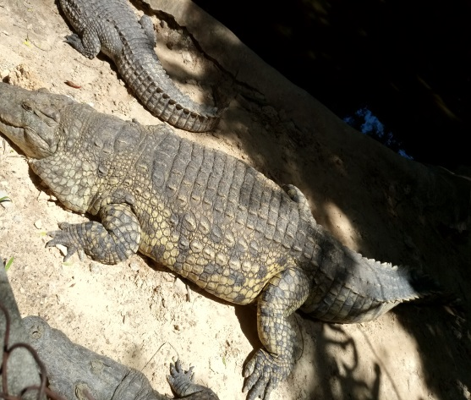 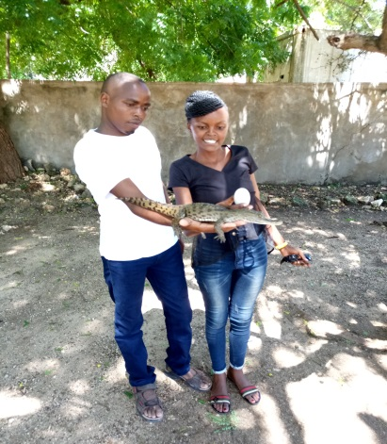

1. **Mombasa Marine Park**.

Experience the white sandy beaches and coconut palms while enjoying the cool breeze along the Kenyan coast beaches in Mombasa Marine Park. You also get a chance to experience the breath taking diving sites and snorkeling. You can also watch crabs, star fish and coral turtles at this destination.

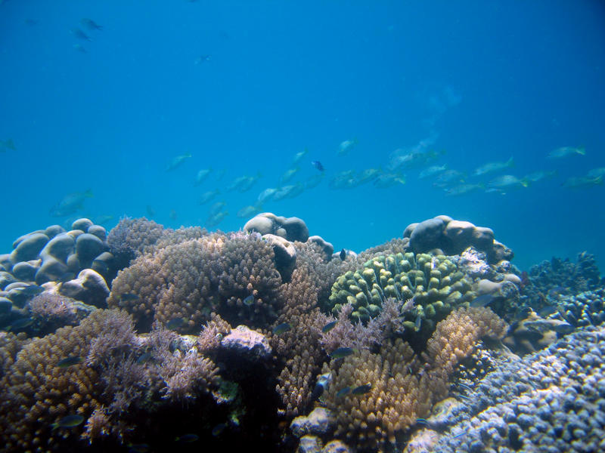

1. Enjoy the coastal culture by socializing with different groups of people at **Jomo Kenyatta public beach,pilate beach, Nyali beach and Shanzu beach**

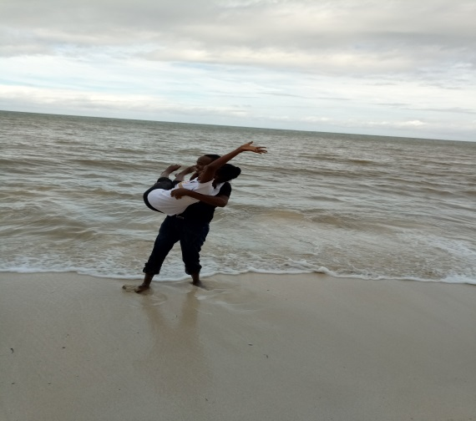

1. Make a visit to the **wild waters** in Mombasa. It has kids’ fun facilities and a nice restaurant with Swahili dishes. This is a very nice place to visit.

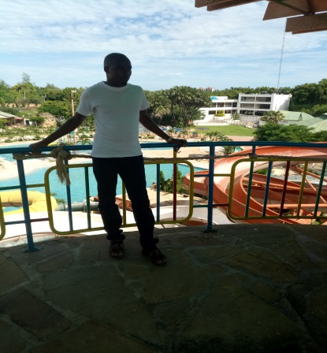

1. As you conclude, do not leave without a visit to **the fort Jesus**. A place of historical monuments and take your time to understand the Kenya history.

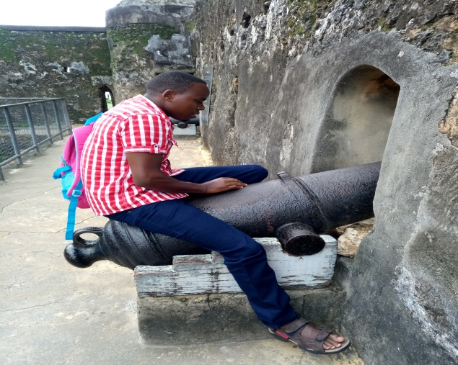

Cost inclusive of

1. 2 way SGR tickets
2. 2. Nights accommodation (Bed and breakfast) at a 4 star hotel.
3. Park entrance fee and guide fees.
4. Transport from SGR to the hotel and vise versa.
5. 2ltr drinking water.
6. Professional photography.

Cost exclusive of

1. Lunch & supper
2. Beach swimming and boat riding cost
3. Any other item not included in the package.

Day one Plan.

1. Meeting at SGR Nairobi terminus at 6:30am.
2. Departure via SGR at 8:00 am
3. Arriving at Mombasa terminus at 2:00pm
4. Transfer to the hotel and arrival at 3:00pm
5. Enjoy the rest of the day at the beach
6. Go back to the hotel for supper, warm swimming at the hotel swimming pool, pool table games, drinks and sleep.

Day two (20th Oct 2019)

1. Break fast at the hotel at 7:00 am
2. Leave for the day’s trips.
3. Arrival at the Haller park 8:00 am
4. Lunch break 12;00- 1:00pm
5. Arrival at Mombasa marine park 2:00pm
6. Leave the park at 4:00pm
7. Arrival at Nyali beach/Jomo Kenyatta public beach.
8. Departure to the hotel at 6:30pm

Day 3 (21st Oct 2019)

1. 7:00 am -Mamba village
2. 9:00 am -Wild water
3. 2:00 pm Departure from Mombasa terminus
4. Arrival at Nairobi terminus.

People depart to their residences